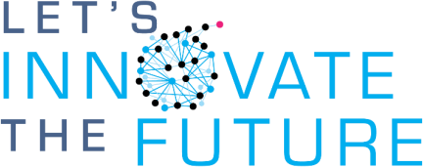

Researchers, students and mentors: “Do you have a pitch perfect idea?”

Wednesday, 7 October 2027

Miran Jarc Library, Novo mesto

PRESENT YOUR IDEA AND WIN 3,000 €
Test your pitch and receive feedback from experts.

Now June - August 2026

17 August 2026
4 September –
6 October 2026

7 October 2026

Future



Register your interest Simply fill in your name and the title of your idea here.

Write down your idea Through workshops and one-on-one sessions, we will assist you in developing your idea!

Submit the application
form
Complete and submit the three-page form.

Practice, practice,
practice!
Through practice presentations, we will help you refine your delivery and message.

Pitch!
Pitch your idea to the commission at ITTC19 in Novo mesto.

Win and implement your idea
Receive additional support in commercializing your invention!

The list of past pitch winners and their ideas can be found here.



Raziskovalci, študenti in mentorji: Imate “pitch perfect” idejo?
Sreda, 7. oktober 2026

Knjižnica Mirana Jarca, Novo mesto

PREDSTAVITE SVOJO IDEJO IN OSVOJITE 3,000 €
Preizkusite svoj pitch in prejmite povratne informacije strokovnjakov.

Danes junij - avgust 2026

17. avgust 2026
4. september –
- oktober 2026

- oktober 2026

Naprej

Oddajte svoj interes Enostavno v obrazec vnesite svoje ime in naslov vaše ideje.
Zapišite svojo idejo Skozi delavnice in individualna srečanja vam bomo pomagali razviti vašo idejo!
Oddajte pisno prijavo Izpolnite in oddajte tristranski obrazec.
Vadite, vadite, vadite!
Pomagali vam bomo izpopolniti vašo predstavitev in sporočilo.
Pitch!
Predstavite svojo idejo komisiji na 19. ITTC v Novem mestu.
Zmagajte in uresničite
svojo idejo Prejmite dodatno podporo pri komercializaciji svojega
izuma!

Seznam preteklih zmagovalcev in naslovi njihovih idej so dostopni tukaj.

